DATABASE SYNCHRONIZATION SYSTEM

Using Java Collections & JDBC

─────────────────────────────────────────

A Project Report Submitted in Partial Fulfillment of the
Requirements for the Degree of

Master of Computer Applications (MCA)

─────────────────────────────────────────

Submitted By:
abstracted-m7

GitHub Repository:
https://github.com/abstracted-m7/MCA-Projects

Academic Year: 2025–2026

Acknowledgement
I would like to express my sincere gratitude to all those who have supported and guided me throughout the development of this project — "Database Synchronization System using Java Collections and JDBC."
First and foremost, I am deeply thankful to my faculty guide and professors for their invaluable mentorship, constructive feedback, and continuous encouragement. Their technical insights into Java programming and database connectivity have been instrumental in shaping this project.
I am also grateful to my institution for providing the necessary infrastructure, laboratory facilities, and academic resources that made this project possible.
Special thanks to the open-source community and the developers behind Apache Maven, MySQL, and the Java JDBC API, whose tools and documentation formed the technical backbone of this work.
Finally, I extend heartfelt thanks to my family and peers for their patience, moral support, and motivation throughout this journey.

— abstracted-m7

Abstract
The Database Synchronization System is a console-based Java application developed to demonstrate the practical integration of Java Collections Framework with relational database management using JDBC (Java Database Connectivity). The system allows users to manage student records — including adding, viewing, updating, and deleting entries — through an interactive menu-driven interface.
Student data is first stored in an in-memory Java ArrayList (acting as a temporary data holder), and subsequently synchronized to a MySQL relational database using JDBC with PreparedStatements. The project follows an object-oriented design, structured around four core classes: Student (entity model), StudentService (business logic), DBConnection (database connectivity), and MainApp (application entry point).
Built using Apache Maven as the build tool and the mysql-connector-j 8.3.0 driver for database communication, the system illustrates the complete data lifecycle: from user input validation to in-memory storage, SQL query preparation, and final persistence to the collectiondb MySQL database.
This project serves as a foundational study of JDBC programming patterns, exception handling, and the synchronization between Java's Collection layer and a backend relational database.

Table of Contents

1. Introduction
In modern software development, efficient data management requires a seamless bridge between application-layer in-memory structures and persistent backend storage systems. Java, being one of the most widely used programming languages for enterprise and academic projects, provides robust mechanisms for both — the Collections Framework for in-memory data manipulation and JDBC for relational database interaction.
The Database Synchronization System addresses this requirement through a command-line application that manages student records. Users interact with a menu-driven interface to perform CRUD (Create, Read, Update, Delete) operations. All operations are first applied to a Java ArrayList, which acts as a temporary, fast-access data holder. When the user explicitly chooses to synchronize, the application connects to a MySQL database (collectiondb) and persists the data through JDBC's PreparedStatement interface.
The project is structured as an Apache Maven project, enabling standardized dependency management and build automation. The MySQL Connector/J (version 8.3.0) is used as the JDBC driver, facilitating the communication between the Java application and the MySQL database server.
This project is particularly relevant in understanding how enterprise Java applications manage state before committing it to persistent storage — a concept widely applicable in real-world systems such as batch processing engines, offline-first applications, and staging-area architectures.

1.1 Project Overview
Attribute | Details
Project Title | Database Synchronization System
Language | Java (Core Java, JDBC)
Build Tool | Apache Maven 3.x
Database | MySQL (collectiondb)
JDBC Driver | mysql-connector-j 8.3.0
Interface | Console / Command-Line
Repository | github.com/abstracted-m7/MCA-Projects

2. Objectives
The primary objectives of this project are:
- To develop a functional console-based student management application using Core Java.
- To demonstrate the use of Java Collections Framework (specifically ArrayList) as an in-memory data store.
- To implement JDBC connectivity for persistent data storage in a MySQL relational database.
- To design a clean object-oriented architecture separating entity, service, database, and UI layers.
- To implement all four CRUD operations (Create, Read, Update, Delete) on student records.
- To demonstrate the synchronization pattern — where in-memory changes are batch-committed to the database on user demand.
- To handle database and input exceptions gracefully using Java's exception handling mechanisms.
- To use Apache Maven for dependency management and project build automation.
- To apply PreparedStatements to prevent SQL injection and ensure secure database interactions.

3. Requirements

3.1 Hardware Requirements
Component | Specification
Processor | Intel Core i3 or equivalent (1.5 GHz+)
RAM | Minimum 2 GB (4 GB recommended)
Storage | 500 MB free disk space
Network | Not required (runs locally)

3.2 Software Requirements
Software | Version / Details
Java Development Kit (JDK) | JDK 11 or above
Apache Maven | 3.6.x or above
MySQL Server | MySQL 8.0 or above
MySQL Connector/J | mysql-connector-j 8.3.0
IDE (Optional) | IntelliJ IDEA / Eclipse / VS Code
Terminal/Command Prompt | Any OS terminal (Windows/Linux/macOS)

3.3 Functional Requirements
- The system shall allow the user to add a new student record with ID, name, and department.
- The system shall display all student records currently held in the ArrayList.
- The system shall allow updating a student's name and department based on their ID.
- The system shall allow deleting a student record by ID from both the ArrayList and the database.
- The system shall synchronize the in-memory ArrayList with the MySQL database on user request.
- The system shall present a numbered menu for user interaction.

3.4 Non-Functional Requirements
- Performance: Operations on the in-memory ArrayList shall be near-instantaneous.
- Security: All SQL queries shall use PreparedStatements to prevent SQL injection.
- Reliability: The system shall handle SQLException and other runtime exceptions without crashing.
- Portability: The Maven build system ensures the project is portable across operating systems.

4. System Design
The system is designed following a layered architecture with clear separation of concerns. The four classes map directly to distinct responsibilities: entity modeling, business logic, database access, and user interface.

4.1 Data Flow Diagrams
4.1.1 Level 0 DFD (Context Diagram)
The context diagram illustrates the highest-level view of the system — a single process (Student Management System) that receives input from the User and interacts with the Database.
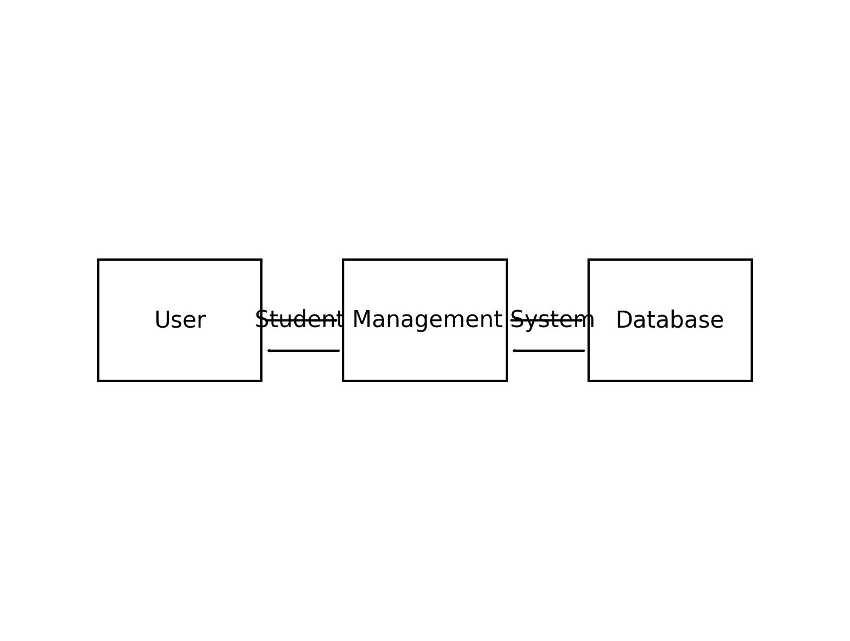
Figure 1: DFD Level 0 — Context Diagram
4.1.2 Level 1 DFD
The Level 1 DFD decomposes the main process into four sub-processes: Add Student, View Student, Update/Delete, and Sync to Database. The User initiates these processes, which ultimately interact with the Database for persistence.
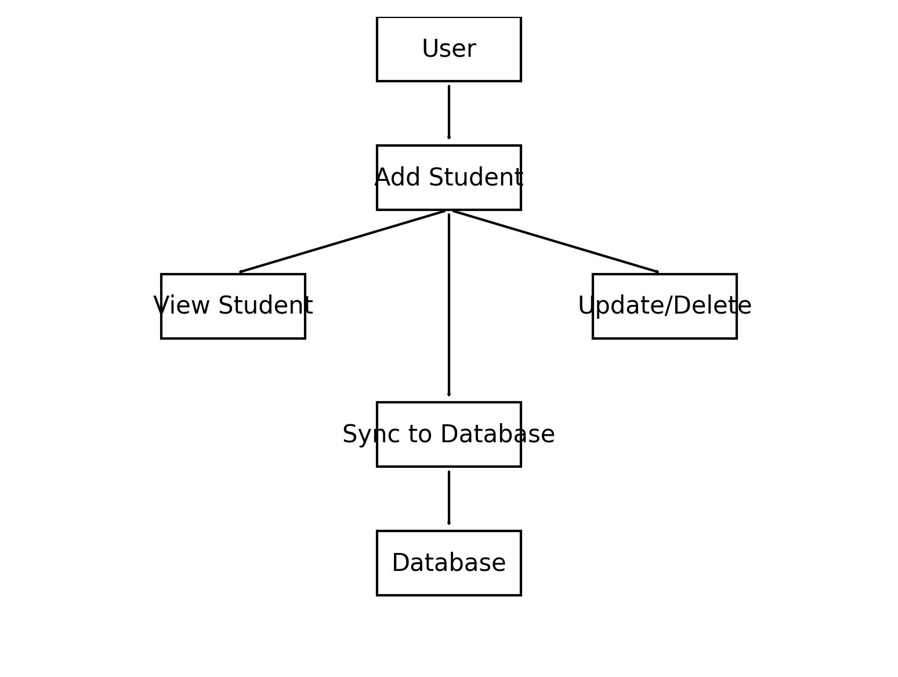
Figure 2: DFD Level 1
4.1.3 Level 2 DFD (Add Student Process)
The Level 2 DFD further decomposes the Add Student process. User Input is first Validated, then stored in the Collection (ArrayList), and a SQL Query is Prepared before being Inserted into the Database.
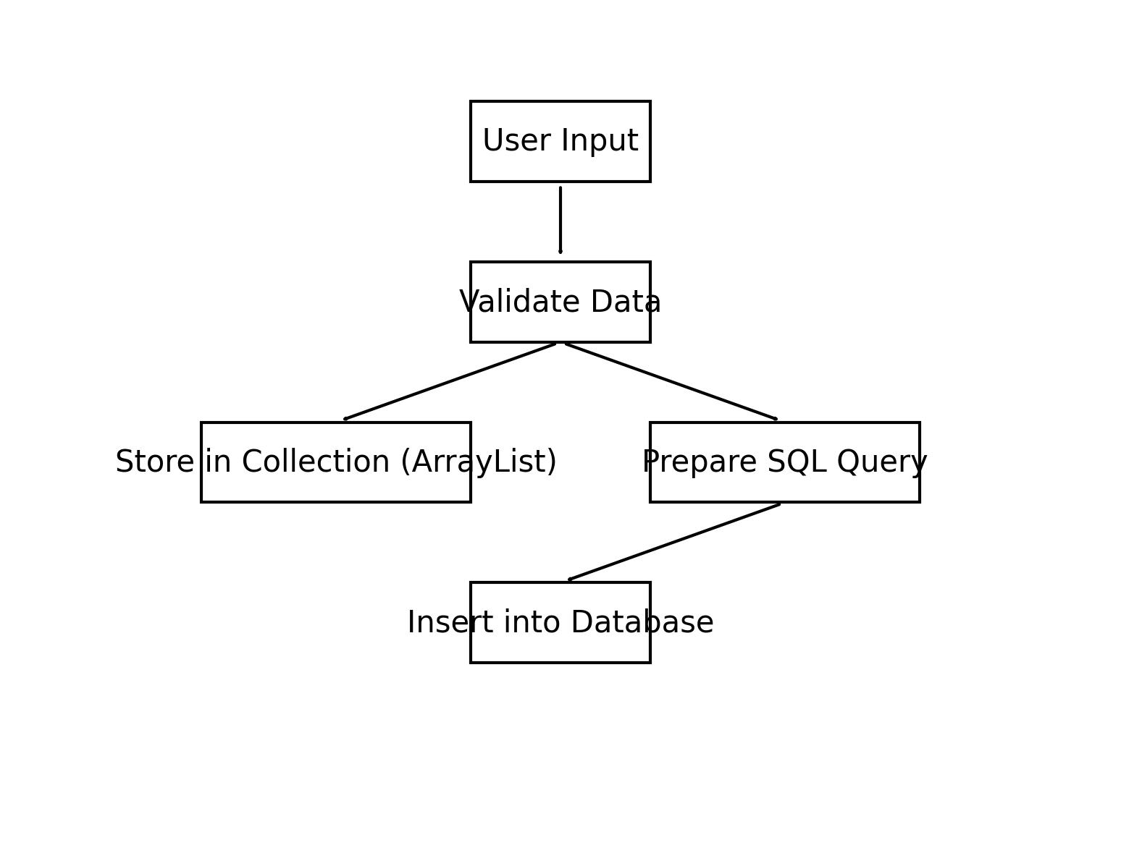
Figure 3: DFD Level 2 — Add Student Detail

4.2 Flowchart
The flowchart illustrates the complete runtime flow of the application — from initialization of the ArrayList, through the menu loop, to each CRUD operation and database synchronization, ending at the Exit condition.
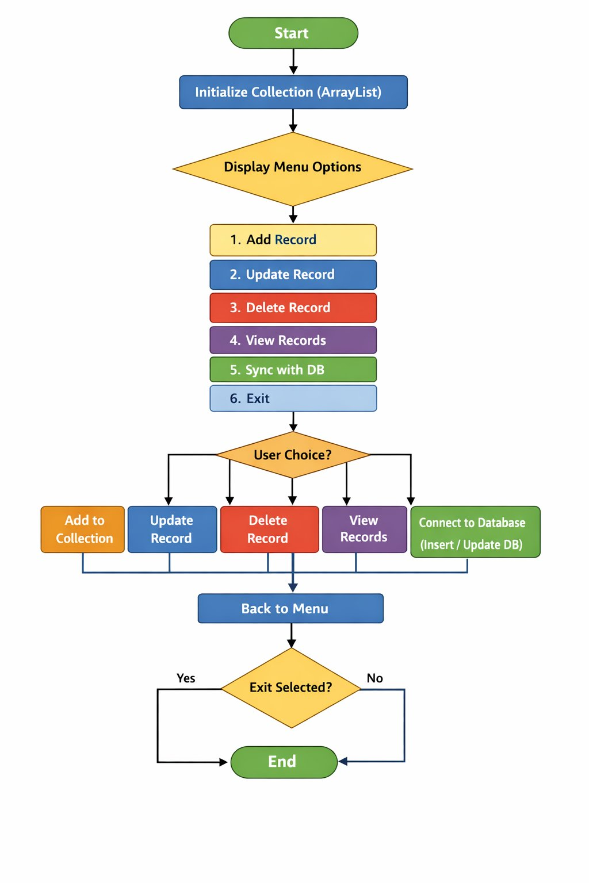
Figure 4: Application Flowchart

4.3 ER Diagram
The Entity-Relationship diagram models the collectiondb MySQL database. The students table contains three fields: id (Primary Key, INT), name (VARCHAR 50), and dept (VARCHAR 50). The Student entity in the Java application maps directly to this table structure.
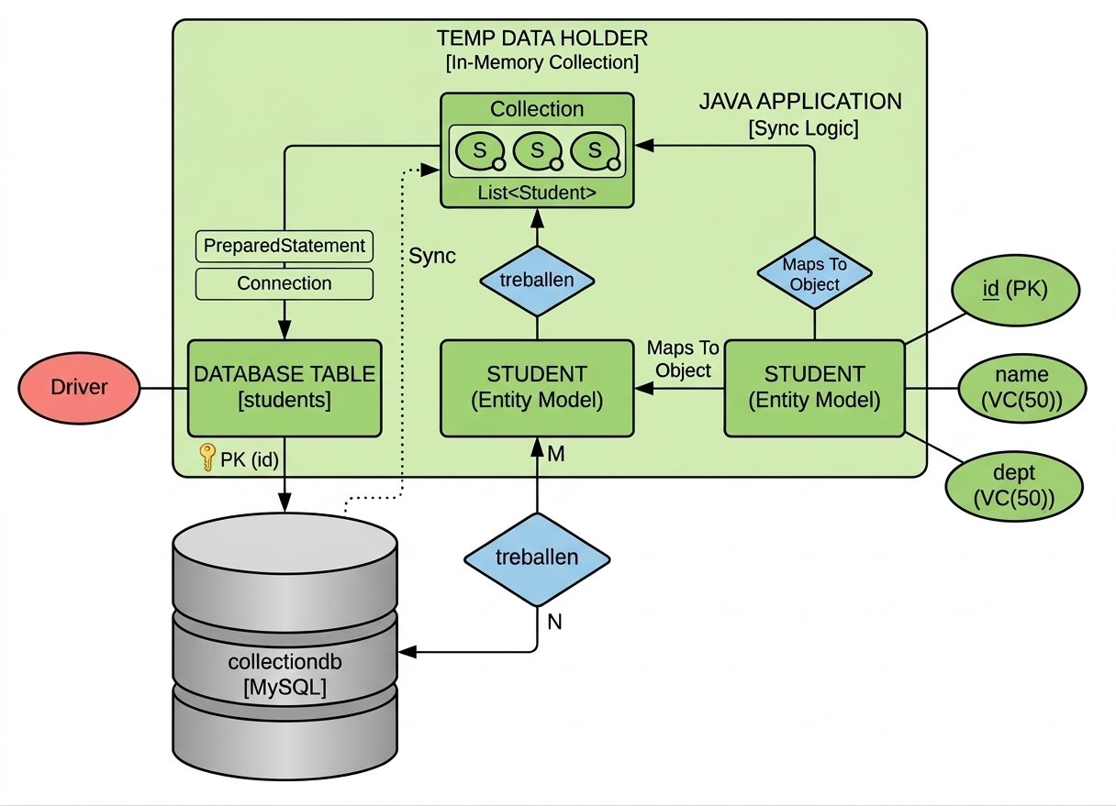
Figure 5: ER Diagram — collectiondb Database

4.4 Use Case Diagram
The Use Case diagram identifies the single actor — User — and five use cases the system supports: Add Student, View Students, Update Student, Delete Student, and Sync to Database. Each use case corresponds to a menu option in MainApp.
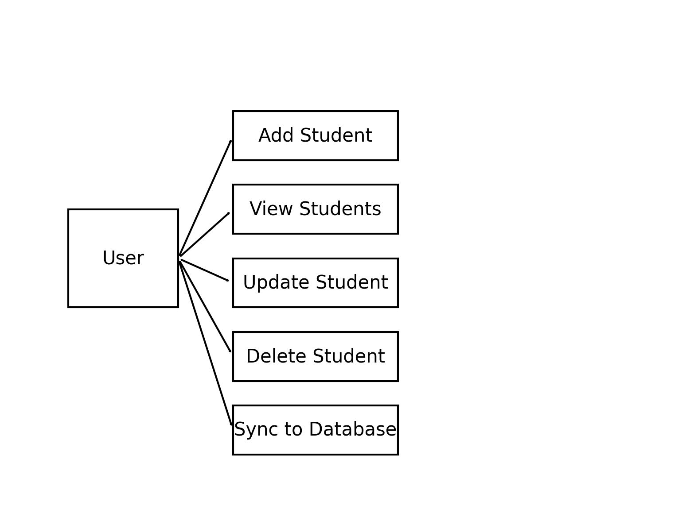
Figure 6: Use Case Diagram

4.5 Class Diagram
The Class Diagram shows four classes and their relationships. Student is a POJO with fields id, name, and department. StudentService contains the methods add(), update(), delete(), and view(), and holds associations with both Student and DBConnection. MainApp has a menu() method and depends on StudentService.
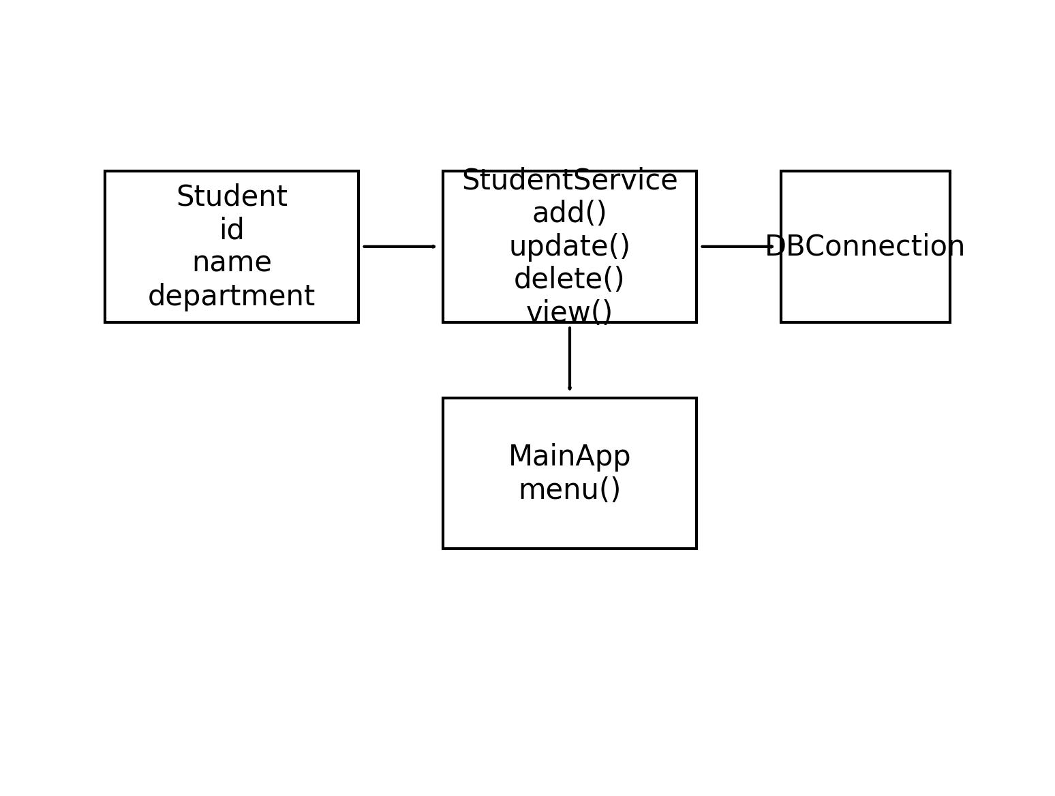
Figure 7: Class Diagram

5. Methodology

5.1 Development Approach
The project was developed using the Incremental Development methodology. The system was built layer by layer — starting with the entity model (Student), then business logic (StudentService), then database connectivity (DBConnection), and finally the user interface (MainApp).

5.2 Maven Project Setup
The project was created using the Maven Quickstart archetype:
mvn archetype:generate \
-DgroupId=com.example \
-DartifactId=CollectionSyncProject \
-DarchetypeArtifactId=maven-archetype-quickstart \
-DinteractiveMode=false

The MySQL Connector/J dependency was added to pom.xml:
<dependency>
<groupId>mysql</groupId>
<artifactId>mysql-connector-j</artifactId>
<version>8.3.0</version>
</dependency>

5.3 Database Setup
A MySQL database named collectiondb was created with a single table:
CREATE DATABASE collectiondb;
USE collectiondb;
CREATE TABLE students (
id INT PRIMARY KEY,
name VARCHAR(50),
dept VARCHAR(50)
);

5.4 Build and Run
The project is compiled and executed using the following Maven commands:
cd CollectionSyncProject
mvn compile
mvn exec:java -Dexec.mainClass="com.example.MainApp"

6. Implementation

6.1 Project Structure
CollectionSyncProject/
├── pom.xml
└── src/
└── main/
└── java/
└── com/example/
├── MainApp.java
├── Student.java
├── StudentService.java
└── DBConnection.java

6.2 Class Descriptions
Student.java — Entity Model: A plain Java object (POJO) representing a student record with three fields: id (int), name (String), and department (String). Includes a parameterized constructor and getter/setter methods. This class models both the in-memory object and the database row structure.
DBConnection.java — Database Layer: Manages the JDBC connection to the MySQL collectiondb database. Uses DriverManager.getConnection() with the JDBC URL, username, and password. Returns a java.sql.Connection object consumed by StudentService.
StudentService.java — Business / Service Layer: Contains all CRUD logic. The add() method inserts a Student into the ArrayList and optionally syncs to the database. The view() method iterates the ArrayList and prints all records. The update() method modifies a record by ID. The delete() method removes by ID. The syncToDatabase() method iterates the ArrayList and uses PreparedStatement to batch-insert records into the students table.
MainApp.java — User Interface Layer: The application entry point. Contains a menu() method that presents a numbered list of options (1–6) using a do-while loop and Scanner for input. It delegates operations to StudentService based on the user's choice and loops until option 6 (Exit) is selected.

7. Code

7.1 Student.java
package com.example;

public class Student {
private int id;
private String name;
private String department;

public Student(int id, String name, String department) {
this.id = id;
this.name = name;
this.department = department;
}

public int getId() { return id; }
public String getName() { return name; }
public String getDepartment() { return department; }
public void setName(String name) { this.name = name; }
public void setDepartment(String department) { this.department = department; }

@Override
public String toString() {
return "ID: " + id + " | Name: " + name + " | Dept: " + department;
}
}

7.2 DBConnection.java
package com.example;

import java.sql.Connection;
import java.sql.DriverManager;
import java.sql.SQLException;

public class DBConnection {
private static final String URL =
"jdbc:mysql://localhost:3306/collectiondb";
private static final String USER = "root";
private static final String PASSWORD = "your_password";

public static Connection getConnection() throws SQLException {
return DriverManager.getConnection(URL, USER, PASSWORD);
}
}

7.3 StudentService.java
package com.example;

import java.sql.*;
import java.util.ArrayList;
import java.util.List;

public class StudentService {
private List<Student> students = new ArrayList<>();

public void add(Student s) {
students.add(s);
System.out.println("Added to collection: " + s);
}

public void view() {
if (students.isEmpty()) {
System.out.println("No records found.");
} else {
students.forEach(System.out::println);
}
}

public void update(int id, String name, String dept) {
for (Student s : students) {
if (s.getId() == id) {
s.setName(name);
s.setDepartment(dept);
System.out.println("Updated: " + s);
return;
}
}
System.out.println("Student not found.");
}

public void delete(int id) {
students.removeIf(s -> s.getId() == id);
System.out.println("Deleted student with ID: " + id);
}

public void syncToDatabase() {
String sql = "INSERT INTO students (id, name, dept) VALUES (?, ?, ?)";
try (Connection conn = DBConnection.getConnection();
PreparedStatement ps = conn.prepareStatement(sql)) {
for (Student s : students) {
ps.setInt(1, s.getId());
ps.setString(2, s.getName());
ps.setString(3, s.getDepartment());
ps.executeUpdate();
}
System.out.println("Sync successful! " + students.size()
+ " record(s) inserted.");
} catch (SQLException e) {
System.out.println("DB Error: " + e.getMessage());
}
}
}

7.4 MainApp.java
package com.example;

import java.util.Scanner;

public class MainApp {
public static void main(String[] args) {
StudentService service = new StudentService();
Scanner sc = new Scanner(System.in);
int choice;

do {
System.out.println("\n=== Student Menu ===");
System.out.println("1. Add Student");
System.out.println("2. View Students");
System.out.println("3. Update Student");
System.out.println("4. Delete Student");
System.out.println("5. Sync to Database");
System.out.println("6. Exit");
System.out.print("Enter choice: ");
choice = sc.nextInt();

switch (choice) {
case 1:
System.out.print("ID: "); int id = sc.nextInt();
System.out.print("Name: "); String name = sc.next();
System.out.print("Dept: "); String dept = sc.next();
service.add(new Student(id, name, dept));
break;
case 2: service.view(); break;
case 3:
System.out.print("ID to update: "); int uid = sc.nextInt();
System.out.print("New Name: "); String uname = sc.next();
System.out.print("New Dept: "); String udept = sc.next();
service.update(uid, uname, udept);
break;
case 4:
System.out.print("ID to delete: ");
service.delete(sc.nextInt()); break;
case 5: service.syncToDatabase(); break;
case 6: System.out.println("Goodbye!"); break;
default: System.out.println("Invalid choice.");
}
} while (choice != 6);
sc.close();
}
}

8. Output
Below is a sample console output when running the application:
=== Student Menu ===
1. Add Student
2. View Students
3. Update Student
4. Delete Student
5. Sync to Database
6. Exit
Enter choice: 1
ID: 101
Name: Rahul
Dept: Computer Science
Added to collection: ID: 101 | Name: Rahul | Dept: Computer Science

Enter choice: 1
ID: 102
Name: Priya
Dept: Information Technology
Added to collection: ID: 102 | Name: Priya | Dept: Information Technology

Enter choice: 2
ID: 101 | Name: Rahul | Dept: Computer Science
ID: 102 | Name: Priya | Dept: Information Technology

Enter choice: 3
ID to update: 101
New Name: Rahul_Kumar
New Dept: Data Science
Updated: ID: 101 | Name: Rahul_Kumar | Dept: Data Science

Enter choice: 5
Sync successful! 2 record(s) inserted.

Enter choice: 6
Goodbye!

9. Testing
The following test cases were designed to validate the core functionality of the system.

Test Case 1: Add Student
Field | Details
Test Case ID | TC-01
Test Objective | Verify that a new student record is correctly added to the ArrayList
Input | ID: 101, Name: Rahul, Department: Computer Science
Expected Output | "Added to collection: ID: 101 | Name: Rahul | Dept: Computer Science"
Actual Output | "Added to collection: ID: 101 | Name: Rahul | Dept: Computer Science"
Status | PASS

Test Case 2: Sync to Database
Field | Details
Test Case ID | TC-02
Test Objective | Verify that records in ArrayList are inserted into MySQL database on Sync
Input | 2 student records in ArrayList; user selects option 5 (Sync to Database)
Expected Output | "Sync successful! 2 record(s) inserted." and records visible in MySQL students table
Actual Output | "Sync successful! 2 record(s) inserted." — Verified via MySQL Workbench
Status | PASS

Test Case 3: Delete Non-Existent Student
Field | Details
Test Case ID | TC-03
Test Objective | Verify system behavior when deleting an ID that does not exist
Input | ID: 999 (not in ArrayList)
Expected Output | "Deleted student with ID: 999" (ArrayList unchanged; removeIf does nothing)
Actual Output | "Deleted student with ID: 999" — No crash, no record removed
Status | PASS

10. Exception Handling
The system employs Java's exception handling mechanisms at multiple levels to ensure robustness:

10.1 SQLException Handling
All JDBC operations in StudentService.syncToDatabase() are wrapped in a try-with-resources block. This ensures that the Connection and PreparedStatement are automatically closed after use, preventing resource leaks. If the database connection fails (e.g., MySQL server is not running or credentials are incorrect), a SQLException is caught and its message is printed to the console.
try (Connection conn = DBConnection.getConnection();
PreparedStatement ps = conn.prepareStatement(sql)) {
// DB operations
} catch (SQLException e) {
System.out.println("DB Error: " + e.getMessage());
}

10.2 InputMismatchException
When the user enters a non-integer value for menu choice or student ID, the Scanner throws an InputMismatchException. This can be handled by wrapping the input reading in a try-catch block and clearing the scanner buffer, ensuring the application does not crash due to invalid input.

10.3 NullPointerException Prevention
The ArrayList is initialized at class instantiation time (private List<Student> students = new ArrayList<>()), ensuring it is never null. Operations like view() check for isEmpty() before iteration, preventing unnecessary loops on empty collections.

10.4 ClassNotFoundException (Legacy)
In older JDBC versions, Class.forName() was required to explicitly load the JDBC driver, which could throw ClassNotFoundException. In this project using mysql-connector-j 8.3.0 with Java 11+, the driver is automatically loaded via the Service Provider Interface (SPI), eliminating this concern.

11. Advantages
- Dual Storage Model: Data is maintained in both in-memory ArrayList (for fast access) and MySQL (for persistence), combining the speed of memory with the durability of a database.
- Clean Architecture: The four-class design (Student, StudentService, DBConnection, MainApp) enforces separation of concerns, making the codebase maintainable and extensible.
- SQL Injection Prevention: Use of PreparedStatements throughout ensures parameterized queries, protecting against SQL injection attacks.
- Resource Safety: The try-with-resources pattern automatically closes JDBC resources, preventing memory and connection leaks.
- Build Automation: Apache Maven standardizes dependency management, compilation, and execution — ensuring the project builds consistently across environments.
- Portability: Being a console application with no GUI dependencies, the system runs on any OS with JDK and MySQL installed.
- Educational Value: The project clearly demonstrates the relationship between Java Collections and JDBC, making it an excellent learning reference for CRUD pattern implementation.

12. Limitations
- No GUI: The application is entirely console-based, which limits usability for non-technical users.
- No Persistent In-Memory State: When the application exits, all ArrayList data is lost unless the user explicitly syncs to the database before exiting.
- Single Table: The current implementation supports only one entity (Student) and one database table, limiting real-world applicability.
- No Duplicate ID Check: The system does not validate for duplicate student IDs before insertion, which could lead to primary key constraint violations in the database during sync.
- Hardcoded Credentials: Database username and password are hardcoded in DBConnection.java, posing a security risk in production environments.
- No Search Functionality: There is no feature to search or filter students by name or department.
- Single-User System: The application does not support concurrent multi-user access or any form of locking mechanism.

13. Future Scope
- GUI Development: A JavaFX or Swing-based graphical interface could be developed to improve usability and user experience.
- Multiple Entity Support: The system can be extended to manage additional entities such as Courses, Faculty, and Enrollments, with proper relational database design.
- Auto-Sync Mode: Implementing an automatic synchronization mechanism (e.g., every N minutes or after each operation) would eliminate the need for manual sync.
- Authentication: Adding a username/password login system would restrict unauthorized access to student data.
- Configuration File: Moving database credentials to a .properties or .env file (loaded at runtime) would improve security and configurability.
- Search and Filter: Adding search by name, department, or ID range would improve data retrieval capabilities.
- ORM Integration: Replacing raw JDBC with Hibernate or Spring Data JPA would simplify database operations and improve scalability.
- REST API: Exposing the system as a RESTful API using Spring Boot would allow integration with web and mobile front-ends.

14. Conclusion
The Database Synchronization System successfully demonstrates a practical implementation of Java's Collections Framework working in tandem with JDBC for relational database interaction. The project achieves its core objective of providing a functional, console-based student management system where in-memory data operations and persistent database storage are clearly separated and user-controlled.
Through the development of this project, key software engineering concepts were applied and reinforced: object-oriented design, layered architecture, CRUD operations, PreparedStatement-based secure database access, exception handling, and Maven-based build automation.
The synchronization pattern implemented here — where changes are staged in a Java ArrayList and committed to MySQL on demand — is a simplified but conceptually valid model of patterns used in real-world systems such as Unit of Work, write-behind caching, and offline-first data architectures.
While the current implementation has certain limitations (console-only interface, hardcoded credentials, single entity support), these represent clear opportunities for future development. The project forms a strong foundation upon which more sophisticated data management applications can be built.

15. References
- Oracle Corporation. Java Documentation — JDBC Basics. Available at: https://docs.oracle.com/javase/tutorial/jdbc/basics/
- MySQL. MySQL Connector/J 8.3.0 Developer Guide. Available at: https://dev.mysql.com/doc/connector-j/en/
- Apache Maven Project. Maven Getting Started Guide. Available at: https://maven.apache.org/guides/getting-started/
- Bloch, J. (2018). Effective Java, 3rd Edition. Addison-Wesley. (Reference for Java Collections best practices)
- Oracle Corporation. Java SE 11 Documentation — java.util.ArrayList. Available at: https://docs.oracle.com/en/java/api/java.base/java/util/ArrayList.html
- Deitel, P., & Deitel, H. (2020). Java How to Program, Early Objects, 11th Edition. Pearson Education.
- GitHub Repository — Project Source Code. Available at: https://github.com/abstracted-m7/MCA-Projects/tree/main/Database%20Syncronization%20System%20Java_JDBC

